2021 Easton Valley Boy’s Track & Field Apparel Shop
(Ends March 20th, 2021)
evboystrack.spiritsale.com

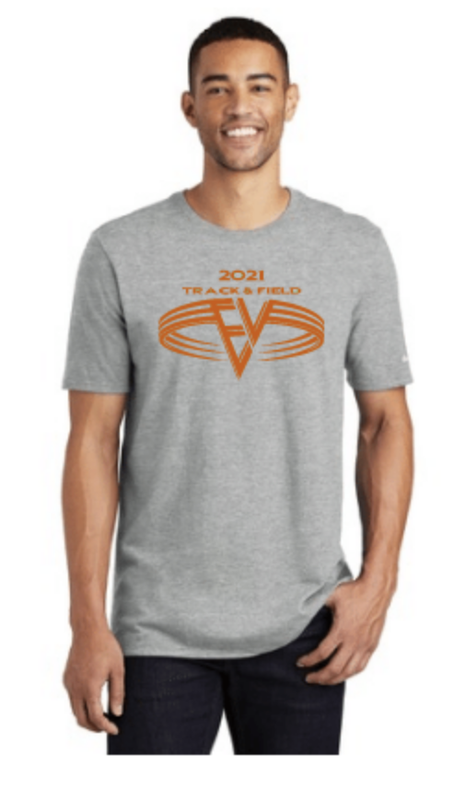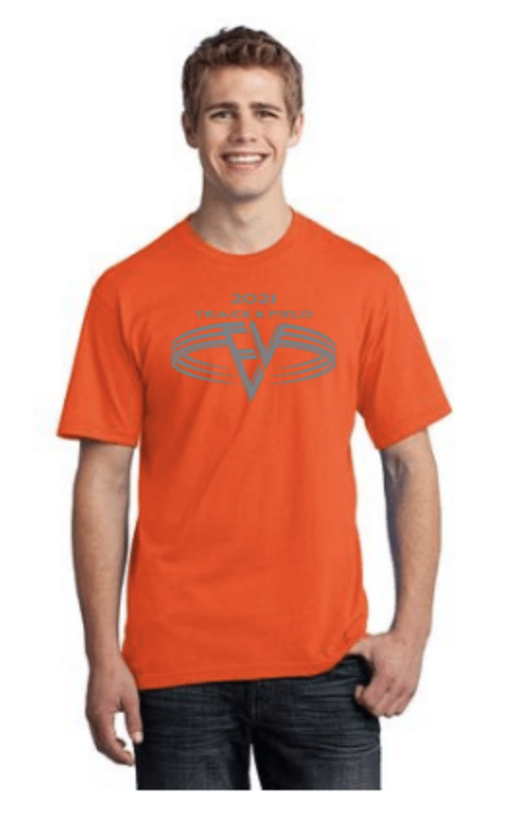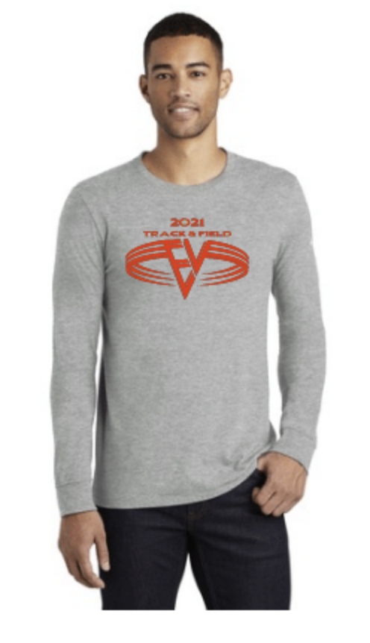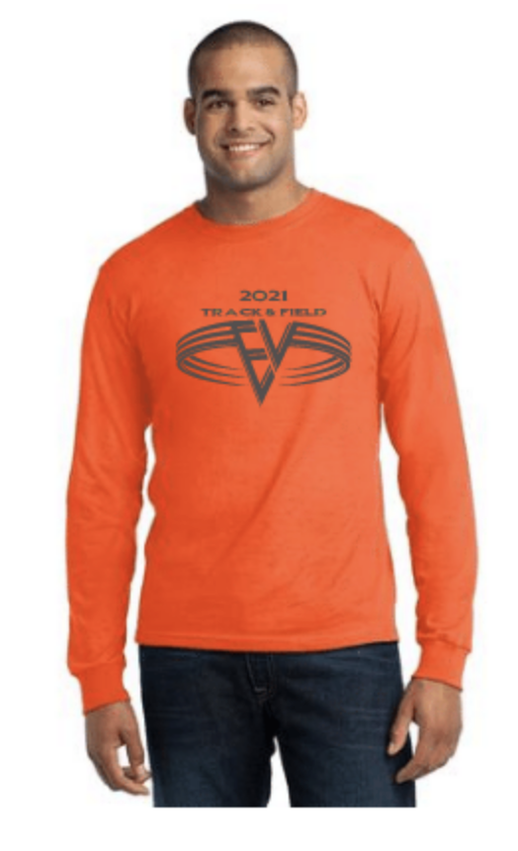
Nike Core Common Tee Port & Company Tee Nike Core Cotton Port & Company - Port & Company
Long Sleeve Tee Long Sleeve Tee Fleece Pullover Hooded

: NKBQ5233 : USA100 : NKBQ5232 : USA100LS : PC90H

From : $22.00 From : $14.00 From : $25.00 From : $18.00 From : $24.00

